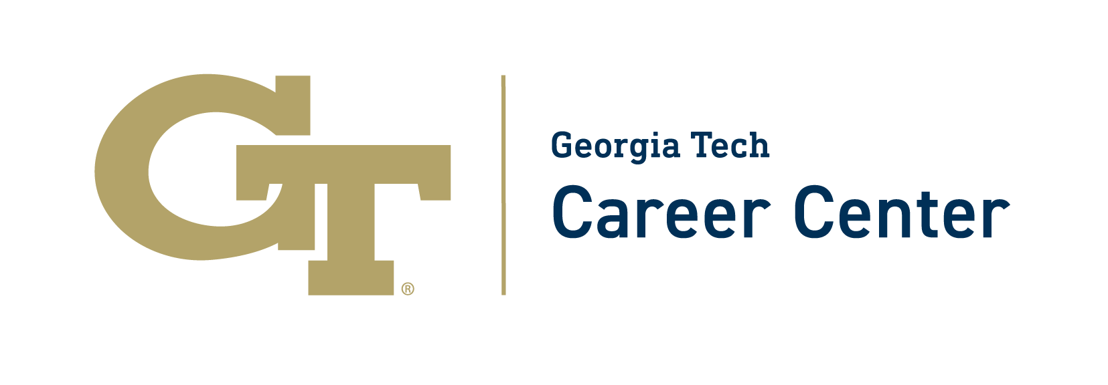

Strategies for Upskilling
This is a great time to consider what resources you have available to you to continue to grow your skills and make yourself a competitive candidate. Consider the following:
- Review the job descriptions in the ES&P archives. Which jobs did you really want, but didn’t yet have the technical skills needed to be a competitive candidate? Are there opportunities for you to grow those technical skills now through some online training or other remote method?
- Utilizing the ONET Online website, begin to research the specifics of various jobs within your desired field. On ONET, start with “Occupation Quick Search” in upper right and enter a simple search term, like “film,” “biology,” or “mobile apps.” The search will bring up a list of possible jobs. Click on the job titles to read what skills and abilities are needed in this job. What are ways that you can grow your skills now?
- 20 Best Free Online Certifications & Courses for 2020
- Rasmussen College is offering online professional certificates through July at no cost. Advance your skills from home for free. Click here.
- Utilize Big Interview to improve your interviewing skills: https://drexel.biginterview.com/login
- Utilize the Drexel Library Guides to learn more about your field: http://libguides.library.drexel.edu/libraryguides
- Utilize the Drexel Library to begin doing literature review on an area of interest and writing a White Paper or report based upon your research
  - BONUS: Publish your work on LinkedIN to start growing your brand
- Join a professional association in your field to network, gain access to career and professional development and other information that can help build your skills: http://libguides.library.drexel.edu/c.php?g=777108&p=6466326
- Software engineering/web development: The Odin Project. It is 100% free from start to finish.
- JobScan has a list of 5 Certifications You Can Add to Your Resume (for Free!)
- TheMuse (a fantastic resource for all things job- and career-related) has a list of 41 Classes You Can Take Right Now to Advance Your Career (and they’re free!)
- Coursera is a famous, free platform for all kinds of courses
  - Leadership, Excel, and many courses looking at the epidemiology of COVID-19, are just a few of the offerings on this site!
- Check out the Handshake Career Center Resource Hub: https://hs.joinhandshake.com/universitycovidresources/
- Attend Virtual Events on Handshake. These are opportunities to connect with employers and gain skills by attending free webinars: https://drexel.joinhandshake.com/events
- For LeBow students, there will be a webinar on April 8th about Maximizing and Leveraging Your LinkedIn Profile
- Not free, but Interesting Engineering has some low-cost Excel courses (and many other low-cost courses!) Udemy is also a low-cost resource for fantastic upskilling courses!
- LinkedIn has a lot of great courses:
  - Leading Virtual Meetings
  - Digital Body Language
  - Effective Virtual Presentations
  - Virtual Networking for Job Interviews
Using this time of isolation to focus on your physical and mental health is primary, and it’s a great time to focus on building healthy habits.
- Yale’s famous course on The Science of Wellbeing is free on Coursera!
- CNN has a great list of general free resources from cooking to reading to fitness!
- Planet Fitness is offering free online fitness classes
- Maybe try yoga!
- Maybe you want to learn how to cook – now might be the time to try one of those Tasty videos you see online all the time.
- Or maybe you already know how to cook/bake and want to learn something specific: Skillshare is free and has tons of videos.

